Honours Project Report
Test driven teaching with advanced web technologies
Connor Forsyth 2020
A report submitted as part of the requirements for the degree of BSc (Hons) in Application Software Development
At
The Robert Gordon University, Aberdeen, Scotland
Declaration
A form declaring the original authorship of the content of the report follows this title page.

Declaration
I confirm that the work contained in this Honours project report has been composed solely by myself and has not been accepted in any previous application for a degree. All sources of information have been specifically acknowledged and all verbatim extracts are distinguished by quotation marks.

Contents
1 Abstract 4
2 Acknowledgements 4
3 Introduction 4
4 Literature Review 4
4.1 Test-driven development 4
4.1.1 Why use TDD? 5
4.1.2 Comparison of TDD with other implementations of Agile development 6
4.1.3 Comparison of the Agile approach with another prominent approach to software development in Waterfall 9
4.2 Exploration of the difficulty’s students face when learning to program 13
4.2.1 Issues faced when learning to program 14
4.2.2 Issues faced when learning the concepts of programming 14
4.2.3 Importance of feedback 15
4.3 Exploration of the issue’s teachers face 16
4.4 Exploration of learning platforms 16
4.4.1 Researcher’s finding of implementing learning platforms 16
4.4.2 Lecturer’s findings on integrating their courses with a learning platform 17
4.5 Underlying technologies used in the development of a learning platform 18
4.5.1 Version Control Software 19
4.5.2 Continuous Integration Software 22
4.6 Summary of Literature Review 23
4.7 References 23
Design 27
Implementation 27

1 Abstract
Enter information here regarding the reason why the project was developed and necessary what did it set out to do and what did it achieve?
Keywords: Test-driven development; Version Control Software; Continuous Integration;

2 Acknowledgements
I would like to give special thanks to Dr. John Isaacs of Robert Gordon University, who without his guidance throughout the project’s development, would not have been successful.
I would also like to thank Github for providing the project with a free organisation account that allowed for the classrooms and assessments to be created , Travis CI for providing a free tier subscription that enabled the project to provide iterative feedback to the repositories, Glitch.com for providing free web hosting of the Github Probot Application and Slack for providing a platform for the students to help one another with any issues with their work.

3 Introduction

4 Literature Review
Throughout this review, the research will aim to define what the test-driven approach to development is and why it will be useful for developing an iterative learning platform for beginner programmers in comparison to other methodologies. The research will explore the issues that can develop in novice programmers and the techniques that can be utilised to prevent or mitigate said issues, the implementations of such learning platforms by various lecturers around the world, the technologies they used to implement such a platform and what they gained from the experience. The project will then delve into what technologies could be used to develop such a system, exploring what they do and how they will integrate to develop a learning platform.

4.1 Test-driven development
First popularised by (Kent Beck, 2002), the test-driven approach is a form of the agile framework to development that is the amalgamation of the test-first approach where you write the test cases required at the beginning before any production level code has been written then refactoring the code until it passes said tests. The basis of which is that by gradually iterating upon the code, improving it with each new attempt until it passes the tests written as shown in figure 1.
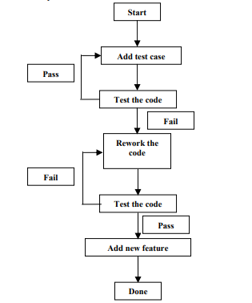
Figure 1 Test-driven development cycle (Scott Ambler, 2007)

4.1.1 Why use TDD?
The overall goal of test-driven development is that by iterating and reiterating on the code you produce, should lead to a cleaner and bug-free solution (Scott Ambler, 2007). The benefit of using such a system is that by thoroughly testing every modification to the code base, you are mitigating the potential for any errors to be missed and pushed to the live service (David Astels, 2003).
Interesting and somewhat unnerving cases of such a scenario have arisen over the years where such errors that could have been avoided, ranging from increasing severity from costing companies and governments millions to hundreds of millions of dollars to the potential loss of millions of lives. In the case of NASA’s Mars Climate Orbiter failure, a wrong conversion rate was used that caused the trajectory of the probe to be off just enough that resulted in the probe’s communications being damaged by the Mars atmosphere (Stephenson et al., 1999). This error not only hindered space exploration but cost over $327 million back in 1999 over something that could have been easily avoided if the contractor, Lockheed Martin, had known to follow the same specification as NASA (Demicoli, 2017).
The opening of Heathrow Terminal 5 was meant to be seen as one of the most significant infrastructure projects at the time and had managed to stay on schedule and on budget, with the new baggage handling system having been thoroughly tested (Brady and Davies, 2010). However, when the software was utilised in a real-world scenario, the system could not cope, resulting in passengers’ bags being left behind and resulted in mass delays with over 500 flights cancelled (Kienitz, 2019).

Figure 2 Passengers queueing in Terminal 5 shortly after opening (Millward, 2008)
As mentioned previously, there has been a case that a software error almost cost millions of people to lose their lives in an instant by nuclear war back in 1983. The Soviet Union’s early warning system raised the alarm that America was going to attack Russia with five nuclear warheads. If it was not for the on-duty officer’s bravery, Stanislaus Petrov, who decided that these alerts were false then we may have seen nuclear fallout which would have been brought about by errors in the software (Aksenov, 2013).
By following the test-driven development approach, programmers learn to develop the most appropriate and efficient code to solve a given problem (David Astels, 2003). The importance of maintainable code is exemplified in industry where maintaining software is already a costly process with estimations showing that roughly 90% of costs on a project are incurred at the maintenance stage of a software’s lifecycle (Dehaghani and Hajrahimi, 2013). By ensuring the code that is written is easy to read and understand and that the functions developed can be reused ensures that costs can be mitigated (Haefliger, Von Krogh and Spaeth, 2008). Ensuring students learn to develop using this methodology, should not only result in the quality of code that they produce to be of higher quality, but will also result in their code becoming more highly maintainable and free from errors.

4.1.2 Comparison of TDD with other implementations of Agile development
The Agile framework has various forms from the scrum methodology to the aforementioned test-driven development approach. The research will investigate the leading iterations of Agile based on the results of a survey overseen by Stack Overflow in 2017.
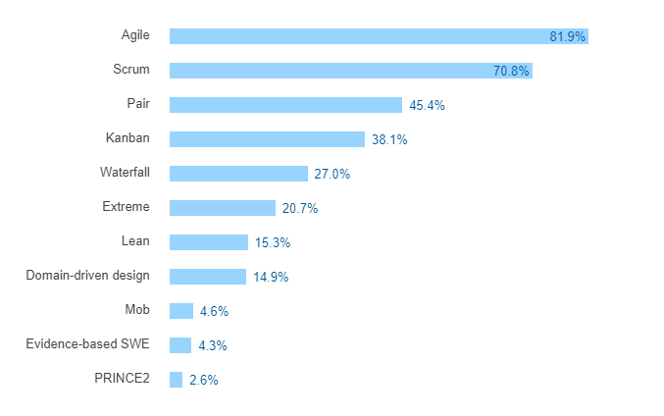
Figure 3 Survey of software methodologies used by developers (StackExchange Inc, 2017)
From the figure above we can see that the two most prominent forms of Agile when excluding pure Agile are Scrum and Pair based on the 20,519 responses from developers around the world.

4.1.2.1 Scrum
The central belief behind Scrum is that in the development of a system there will always be volatile variables such as requirements and time frames that are prone to change throughout the development which can introduce uncertainty and unwanted risk to the process (Abrahamsson et al., 2002). When utilising Scrum, a company will discuss with the client to identify and prioritise the features required to deliver a new product which is recorded in what is called the Project Backlog (Scrum Institute, 2007). This document is regarded as a “living” document in that it is updated continuously throughout development with requirements consistently being ranked under priority and the estimated cost (Abrahamsson et al., 2002).
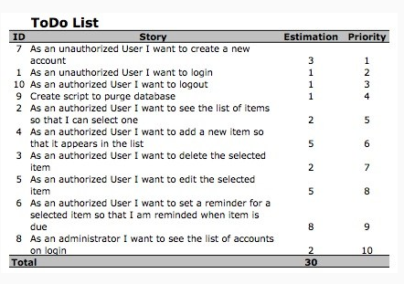
Figure 4 Example Project Backlog (Scrum Institute, 2007)
Software developed using Scrum are iterated over what is referred to as “Sprints” which is typically between two to four weeks in length (Hossain, Ali Babar and Paik, 2009). Before a sprint may begin a sprint review meeting will occur with the client and the company where they discuss and agree upon the work to be carried out in the next cycle (Hossain, Ali Babar and Paik, 2009). Consulting with the client regularly ensures that the team are developing a product that is in line with the customer’s needs and minimises the risk of the team misinterpreting the requirements.
Once the sprint review has been signed off, the next sprint will begin, and in doing so, the deliverables for the sprint are locked in and cannot be changed (Blueprint, 2011). According to findings by (Rising and Janoff, 2000) that for Scrum to be successful, each member of the development team must know what they have been tasked with and what their role is for the current sprint. At the beginning of each day, the development team will convene for a short ten-fifteen-minute meeting to discuss what each member has done and what they plan to work on that day. This allows the development team to continuously keep track of the progress of the current sprint and allows the team to discuss any issues that they have encountered (Abrahamsson et al., 2002).

4.1.2.2 Pair
The focus of pair programming is to have two developers working together on a single computer to deliver new functionality (Wells, 1997). In this setup, one person is designated as the “driver” who is in control of the keyboard and mouse and is writing the code while the other, the “observer” is actively reviewing what the “driver” is writing (Williams et al., 2000). While this is ongoing, the observer will be actively looking for other ways of implementation that may be more efficient (Williams et al., 2000). The programmers will switch roles with one another every few minutes or so, so that both developers have equal input into the development of the product (Agile Alliance, no date). It is argued that pair programming is beneficial for learning purposes where more experienced members of staff can teach the lesser experienced staff to use the techniques that they have learned as a result of their experience (Agile Alliance, no date).
The critical difference between test-driven, scrum and pair are in the number of developers used in each methodology. Scrum is more appropriate when developing within a team as the tasks of the sprint can be evenly spread amongst the team, and any issues can be resolved as soon as possible. Pair programming is beneficial for the diffusion of knowledge, as it allows developers with knowledge of the system to train other members of the team. While test-driven development is more appropriate for individual learning.

4.1.3 Comparison of the Agile approach with another prominent approach to software development in Waterfall
Throughout the industry, teams have over the years developed projects using different approaches depending on the situation varying from Waterfall to Agile.
The traditional method to software development, Waterfall, is an older approach that has technically been around since the 70s. Doctor Winston Royce’s influential article, “managing the development of large software systems” (Royce, 1970), outlined the fundamentals of software development that formed the basis of what we know today as Waterfall (Casteren, 2017). The Waterfall model, as its name implies, is a sequential process to software development. As outlined in the figure below, each stage must be finished before moving onto the next one.
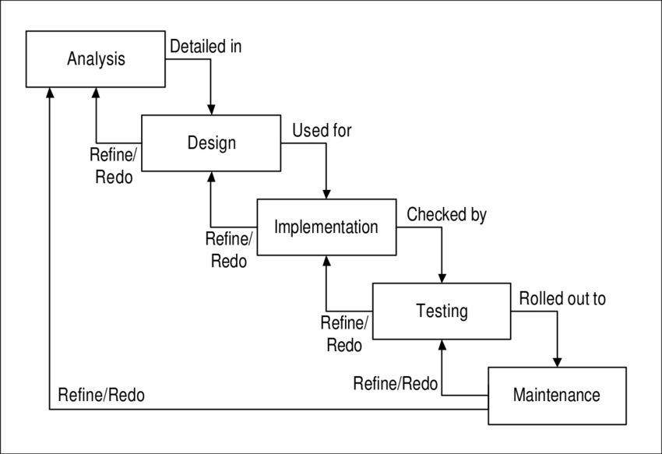
Figure 5 Waterfall development life cycle (Gröner and Nance, 2002)

4.1.3.1 Ability to respond to changing requirements
Project requirements in industry are rarely defined and set in stone (Zowghi and Nurmuliani, 2002; Winters, 2003). Requirements of a project can change over the course of a project’s lifecycle which can be as a result of various factors within a developers control such as the needs of the client/stakeholder changing as the project progresses and in cases where requirements have been identified to be unclear or incomplete (Highsmith and Cockburn, 2001; Zowghi and Nurmuliani, 2002). Unforeseen factors such as new government legislation that could result in the software needing a design overhaul to be more accessible than before to circumstances where the current company has been taken over, and new practices are implemented that employees must now follow (Zowghi and Nurmuliani, 2002).
Before agile was popularised, requirements gathering tended to be done using the waterfall method of software development. Developers would be given a problem by a client and given the task of identifying the requirements and translating those requirements into a vast word-processed document for the customer to sign off at the beginning of the project (Davis Alan, 2004). The issue of using such a methodology is that without thoroughly consulting with the client, the developer may have misunderstood what the client requires and as such be wasting time and money on developing an unusable product which may not be discovered until the completion of the project (Davis Alan, 2004). Utilising the agile approach prevents this issue from occurring as the client is involved regularly during development meaning that if any requirement has been misinterpreted, the problem can be rectified quickly (Rasmusson, no date).
Client involvement within a project is vital to ensuring a project’s success regardless of the industry in question. Lack of client involvement in the past as such was the case in Saudi Arabia in 2013, were at the time they had over 3000 projects delayed in the construction sector, resulted in projects going over budget, over schedule and lead to increased maintenance costs (Trigunarsyah and Solaiman, 2016). The importance of client involvement on the overall success of a project is further highlighted on the surveys displayed below that was carried out by The Standish Group where they surveyed IT executive managers for what factors they deemed necessary for a project to succeed and the factors that made completing a project much more difficult.
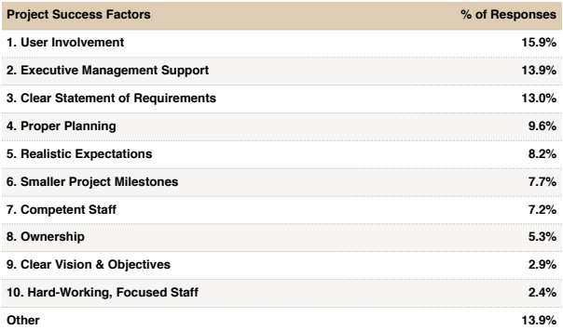
Figure 6 List of factors attributed to project success (The Standish Group, 1995)
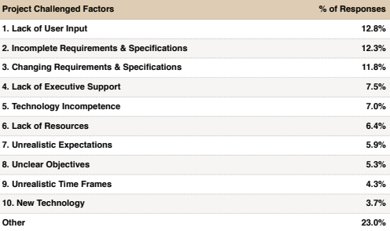
Figure 7 List of factors attributed to project failure (The Standish Group, 1995)

4.1.3.2 The perils of scope creep
Whilst client involvement has been shown to be one of the main factors in increasing the chances of a successful project (The Standish Group, 1995). It is argued that there must be a balance if requirements are regularly changing (Cottmeyer, 2009). Instances of where requirements are being added, removed and altered during the course of the project are often referred to as requirement volatility (Thakurta, 2013). Previous bodies of work have indicated that requirement volatility is one of the major problems that can occur during development (Curtis, Krasner and Iscoe, 1988) and that by neglecting to factor this in can lead to increased expenditure on the project (Dehaghani and Hajrahimi, 2013). Learning how to balance the demands of a client within the time constraints of a given project is something that students will need to learn as part of their degree so that they are sufficiently prepared if it occurs once they have a job in the industry.

4.1.3.3 Usage of the methodologies within industry
As the research has discussed beforehand, the Waterfall method to software development has been around for decades when, in comparison to the relatively new methodology of agile. Viewing methodology usage within the industry will be beneficial for the research to investigate as it will further cement the importance of agile and thusly why learning how to use the test-driven approach for students in terms of their degrees.
Over the years, the agile methodology of development has become more and more prominent within organisations as outlined in the figure below.
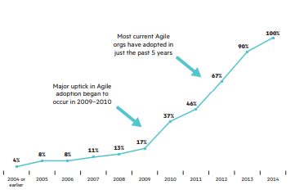
Figure 8 Agile adoption over time (Hewlett Packard, 2014)
The figure above outlines the uptake in usage of agile with organisations that had previously utilised some form of agile before. The statistics show that within these companies that agile has grown exponentially in usage over the last decade. A factor that may have contributed to the uptake in agile may be due to the higher success rate of projects implementing agile over waterfall which has been highlighted in the chaos report produced by (The Standish Group, 2015).
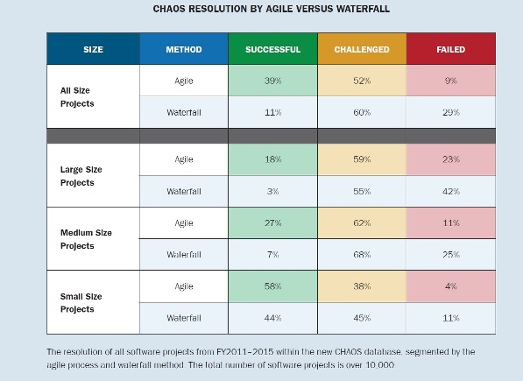
Figure 9 Agile vs Waterfall project success rate (The Standish Group, 2015)
The Standish Group defined three main outcomes based on whether a project managed to stay on schedule, stay within budget and meet all requirements. If the project is able to meet all three conditions, it is valued to have been a success, if a project is challenged it means that one of the three constraints has not been met and a failed project is one that is either cancelled or never utilised upon completion.
The report identifies that no matter the scale of the project that agile is proven to be much more successful in ensuring a project succeeds, with a higher success rate and lower failure rate when compared to waterfall. This statistic may be an insight into the reasoning behind why more and more organisations are preferring to utilise agile over waterfall. Although the report outlines that agile has a better success rate there is nothing to say that a project will succeed just because a project is being developed using agile which is shown by the overall success rate as the project scale increases.
Hewlett Packard Enterprise back in 2014, surveyed over 601 development and IT professionals to determine the impact the agile methodology was having on the industry as outlined in the figure below.
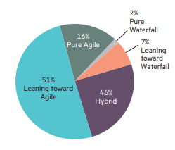
Figure 10 Usage of agile within the industry (Hewlett Packard Enterprise, 2014)
As we can see from their findings and when we factor in the responses shown earlier by Stack Overflow that the industry predominately utilises some form of Agile in software development, reiterating the necessity and importance for students to learn to develop using a form of Agile before they graduate.

4.2 Exploration of the difficulty’s students face when learning to program
Learning something completely new can be a daunting task, whether that be a foreign language or any skill. In both scenarios, you first need to have a clear understanding of the underlying concepts and have a goal in mind to learn effectively (Black, 2006). Thus, for a learning platform to succeed and be effective, the research first needs to identify the issues students may face and find ways to mitigate these issues as much as possible.

4.2.1 Issues faced when learning to program
Research carried out by (Lahtinen, Ala-Mutka and Järvinen, 2005) and (Mhashi and Alakeel, 2013), discovered that the most challenging issues that novice programmers faced in terms of learning to program were in identifying errors in their own work and fixing those faults and designing a solution for a given problem. Understanding how to overcome these issues are crucial for a students’ learning as if the students can, for instance, discover the error in their code and fix it, it proves that they have a better understanding of why the error occurred and as such improve upon their understanding of how their code functions (Black, 2006).
In both studies, other issues were also identified of which the importance of these issues fluctuates based on the study. The studies outline that students also suffer from issues such as learning how to effectively divide the functionality into procedures, understand the syntax of programming languages and understand programming structures and having access to computers.

4.2.2 Issues faced when learning the concepts of programming
The main obstacle that students must overcome when learning the abstract concepts of programming, from error handling to arrays, is to transfer these ideas that they have learned from the lecturer and solve a given problem programmatically (Black, 2006). Understanding how these concepts work in practice allows the students to become more proficient (Black, 2006).
When identifying the issues that students had, the studies from (Lahtinen, Ala-Mutka and Järvinen, 2005) and (Mhashi and Alakeel, 2013) had an overlap in terms of their findings over what concepts the students struggled with more. However, before the research can go into any more detail, the research must note that the study carried out by Lahtinen, Ala-Mutka and Järvinen was conducted using 559 students and 34 teachers from five universities around Europe whereas the study carried out by Mhashi and Alakeel was conducted using 143 students from one university. So it could be argued that the first study gives us a better representation of the struggles students face overall, whereas the second study may only identify the issues students face within the courses taught at that university.
The research undertaken by (Lahtinen, Ala-Mutka and Järvinen, 2005) identified that the most challenging concepts for novice programmers to learn were:
- Pointers and references
- Error Handling
- Recursion
Whereas the research conducted by Mhashi and Alakeel identified that these three concepts were the most challenging for the students:
- Pointers
- Usage of understanding library functions
- Recursion
One factor in distinguishing between the two studies was that difficulty of computer access might be a more significant issue in one country than another, which may adversely affect a student’s ability to reinforce their knowledge.

4.2.3 Importance of feedback
Providing feedback is imperative to a student’s learning (Clynes and Raftery, 2008), concise and effective feedback whether that be from assignments or from the development environment they use can be used to reinforce their understanding of the abstract concepts of programming and on how to implement those concepts into practice.
When learning how to apply those concepts programmatically, students must be provided with feedback through three main areas (Butler and Morgan, 2007):
- Feedback from the teachers
- Feedback from the development environment used
- Feedback from testing
Feedback from the teachers is a necessity to ensure that students are able to understand the abstract concepts from the very start of their computer-science related course (Butler and Morgan, 2007). Feedback in this scenario will most likely be as a result of interactions with students in the class, answering their questions and guiding them towards the correct solution when they have an issue understanding a problem with their code (Black, 2006; Butler and Morgan, 2007). On the contrary, (Mhashi and Alakeel, 2013) argues that by providing more exercises and coursework’s that are relevant to the topic will reinforce the student’s knowledge and understanding and thus improve their programming skills. Feedback from coursework’s to the students must ensure that students are given the necessary feedback for not only the functionality of their program but of the quality and of the design (Butler and Morgan, 2007).
Coinciding with the importance of feedback received from teachers, the feedback received from the development environment (IDE) that the students use to program in and how they test their work will be influential in how a student develops an understanding of debugging their own work (Butler and Morgan, 2007). The development environment will give the user extremely specific error messages detailing what went wrong and where the error occurs in the code when they attempt to compile their work. Using the information provided by the IDE should allow students to gain experience in troubleshooting issues within their code.
As the research has shown so far, for a learning platform to succeed, it must ensure that the feedback given to the student is balanced. Too much help and the students may grow reliant on the platform to resolve all their issues, and if given too little help, the students may become stuck and discouraged. The platform will need to ensure to help students in areas such as debugging and in programming concepts such as arrays if they are struggling.

4.3 Exploration of the issue’s teachers face
Ensuring students understand the fundamentals of programming is an integral part of teaching (Sentance and Csizmadia, 2017). It was argued that beforehand, teachers used to coddle students in that they would complete all the exercises together and in doing so, the students failed to sufficiently develop their problem-solving skills to solve a given problem (Baldwin and Macredie, 1999). It is more beneficial for teachers to take a step back and let the students learn to implement the concepts into practice by iterating upon their work and learning from their mistakes themselves as it will only serve to reinforce their understanding (Feliciano, Storey and Zagalsky, 2016).

4.4 Exploration of learning platforms
Before developing a learning platform, the research first needs to identify how others around the world have implemented similar platforms and discover any shortcomings these platforms may have faced so that the research can avoid following those missteps.

4.4.1 Researcher’s finding of implementing learning platforms
Various researchers around the world have integrated version control systems into their courses to develop a learning environment that encourages collaboration between students (Lawrance, Jung and Wiseman, 2013; Feliciano, Storey and Zagalsky, 2016).

4.4.1.1 Identified benefits of using a learning platform
In both studies, the researchers opted to use a version control system such as Github as the primary learning environment for the students to use. When utilising the system, the researchers found that the students were collaborating with one another using the issues functionality within each other’s repositories to help one another resolve issues that they couldn’t figure out themselves. (Feliciano, Storey and Zagalsky, 2016) identified that the skills they gained from this experience had a positive effect towards the other modules the students had. Learning to collaborate with others has been shown to improve the student’s ability to critically think and improves upon their teamworking skills which are vital in the workplace where developers will be working together on projects (Gokhale, 1995).
It was noted that students found viewing the commit history of their repository beneficial for their learning as they recognised the importance of reviewing their past mistakes and how they delivered the final product.
In another study undertaken by (Zagalsky et al., 2015), they recognised that students could receive specific feedback on an issue with their code by opening a new issue and tagging their teacher into the issue. This allowed teachers to keep track of the progress made by the students that they may not have been aware without using the system.

4.4.1.2 Identified issues found when using a learning platform
On the research conducted by both studies, they found several flaws with their implementations. (Feliciano, Storey and Zagalsky, 2016) found that depending on the teacher’s prior experience or lack thereof on using version control systems can cause a negative effect in the students understanding of using the system to its fullest potential which may have had the adverse effect of reducing the potential for collaboration. In that same study, the student’s identified that having a specific lecture on using Github at the beginning of the course would have been beneficial for their learning and their understanding. (Lawrance, Jung and Wiseman, 2013) argues that although the process of getting used to using the system took time for the students to learn, there was a more pressing issue in that some of the students were only working from the master branch and as a result had more difficulty in merging changes due to the increase in conflicts.
(Feliciano, Storey and Zagalsky, 2016) also outlined the students concerns about using public projects. The students were concerned that the work they carried out may not be something they want to be displayed to the public as there was the risk that their repositories could be found by future employers which may negatively affect their chances in receiving a job after graduation. However, that same study discovered that some of the respondents in the study when looking for jobs had been asked by potential employers to include their Github account as part of the hiring process so using private repositories may have a negative effect when the students start looking for jobs once they graduate.
One of the main drawbacks that both studies noted was that teachers could not simply rely on the version control system for coursework submission as the system simply doesn’t have the required functionality to do so. It may mean be beneficial for the learning platform that the research develops, to find a way to integrate a version control system with a course management system.

4.4.2 Lecturer’s findings on integrating their courses with a learning platform
Whereas the research has identified that studies have utilised version control systems to create a learning platform in the past, those same papers failed to investigate the viability of utilising continuous integration software to provide further feedback for the students.
Lecturer’s argued that by integrating continuous integration software with Github, students were able to build on their knowledge, understanding and confidence by receiving constant feedback whether they were passing or failing the tests run by the continuous integration software (Gennarelli, 2017; Zamansky, 2019). This meant that students didn’t have to wait for their teacher to finish marking their work to find out whether they had solved the given problem or not (Gennarelli, 2019). On the opposite side of this argument, the teachers were able to see the student’s tests and give feedback accordingly. If the students were struggling, the teacher could resolve the issue quickly as opposed to finding out later in the module (Gennarelli, 2017).
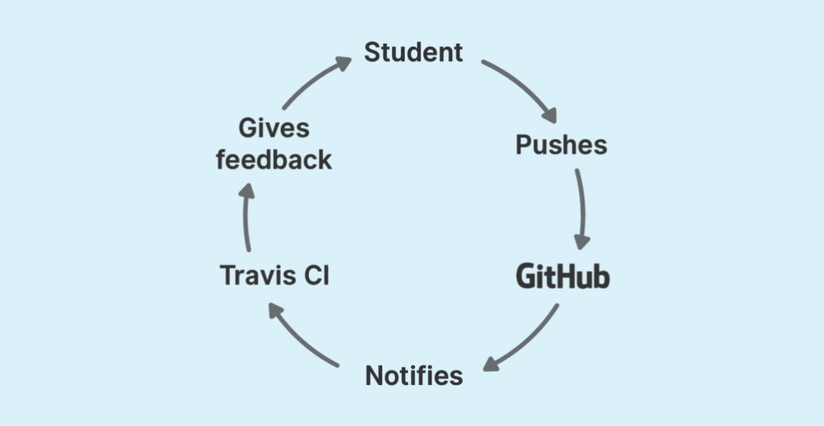
Figure 11 Workflow of a learning platform using a version control system and continuous integration software (Gennarelli, 2019)
On top of the benefits that continuous integration software has for students to better understand where they’ve gone wrong in their code, it can also be extremely useful for students in coursework submissions as it will give the student’s piece of mind that what they’ve made actually works as intended (Zamansky, 2019). Utilising the learning platform on their course, Dr Shane Wilson saw a remarkable improvement on the pass rate of his course, from 51% to 87%, and an increase in student satisfaction when compared to previous years (Gennarelli, 2019). Alongside this, it has been noted that lecturers found that the learning platform gave them further insights into how the students were progressing with their work as they could see the volume of commits the students were making. Using this, the lecturers were able to help those that were struggling.
One major drawback was noted in these implementations in that the continuous integration software couldn’t complete a build that had an infinite loop and as such the lecturer had to check for any stalled builds regularly.
As the research has identified throughout, ensuring students learn for themselves is an extremely important factor in reinforcing their knowledge and understanding and utilising continuous integration will allow for this to happen.

4.5 Underlying technologies used in the development of a learning platform
As the research has discovered, to develop an effective learning platform, the platform needs to utilise the file storage system of version control systems and the testing systems of continuous integration software. The research will explore the importance of the identified technologies and what they do.

4.5.1 Version Control Software
For any form of project whether that be a literature review or a coding project having a backup strategy is imperative to ensure that no progress is lost in the event of a catastrophic failure such as hardware failure (Loeliger and McCullough, 2012). A typical backup strategy will utilise some form of version control where you can track the changes made and this where version control systems come into play. This becomes especially important within the industry where, for instance, you are developing a new product. The product will undergo changes with time, whether that be for fixing errors or developing new features, as time goes on new versions are released and with each release the software slowly evolves, the need to track these changes becomes imperative as the product grows in size (Plaice and Wadge, 1993).
Version control systems or VCS, are a type of software utility that allows users to track and manage changes made to a project in a central repository that is typically hosted off-premises (Atlassian, 2019). The files hosted on said repository can be used to backup anything from word documents to a student's coursework (Kanawade, 2017). On top of having the ability to securely store a backup of all the work you’ve done, version control systems offer a wide range of features from giving you further insight into the changes made and allowing multiple users to collaborate on the project at the same time without interfering with one another.
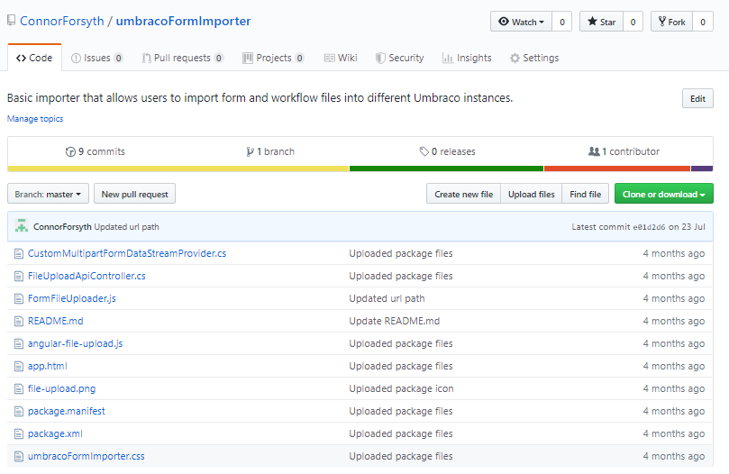
Figure 12 Example of a generic repository hosted on Github (Forsyth, 2019)
The growing importance of version control systems within the industry is evident by the current number of developers utilising the version control system Github. Github has reported that there are now over forty million developers using the system with over forty-four million repositories created in the last year alone (Github, 2019). Ensuring that students learn how to utilise these technologies will be vital for their careers as it will sufficiently prepare them on utilising the technologies effectively.

4.5.1.1 Branching
One of the main objectives of version control systems is providing teams with the ability to collaborate on a project together at the same time without affecting each other’s work (Radigan, 2017). The feature within VCS’ that allows this to happen is called branching. A branch is essentially a direct copy of the original work, typically regarded as the master branch, so that a developer can continue on implementing new features or resolve any bugs found with the product without risking the stability of the current released product (Loeliger and McCullough, 2012; Nagele, 2015). Once the developer is content with the changes made on the branch they can then merge their changes back into the master branch (Nagele, 2015). A typical workflow of branching is outlined below.
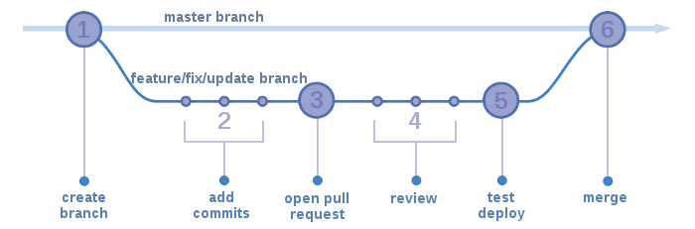
Figure 13 Workflow of branching in version control systems (ARCC, 2018)
As shown in the above diagram, no work is directly done on the master branch. If any changes are required, a new branch is created and developed on and once the changes have been fully tested the alterations can be integrated into the master branch.
Another vital usage of branching as the name of the system implies is controlling the differing versions of the codebase. For instance, a team may be developing an overhaul of their current product and in doing so want to keep an older release separate. The reason for this may be that the overhaul utilises newer technologies that some of their customers cannot use on their hardware. By keeping the releases separate, the team can insure that they can focus on development on the newer version whilst also continuing to support the old one (Loeliger and McCullough, 2012).

4.5.1.2 Commits
A commit is when a developer makes a change to the content on a file or set of files and saves those changes to the codebase (Dabbish et al., 2012). Whenever a developer saves those changes, the version control system will keep a complete record of what files were changed, what the changes were inside those files and who made those changes (Github, no date). The commit history can be extremely beneficial for a team as it allows individuals to understand what everyone on the team has been working on and the changes they’ve implemented as shown in the figure below.
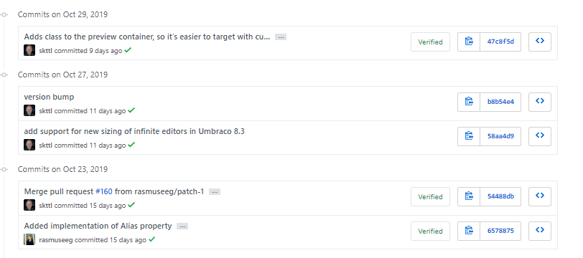
Figure 14 Example of a commit history of a project hosted on Github (Kottal, 2019)

The commit history is also extremely useful for diagnosing issues that have occurred after various changes have been made to the codebase. The feature known as Diffing allows developers to navigate through the history of a given file to determine what changes might have caused the error.
On a teamworking module that utilises some form of version control software, the lecturer may wish to view the commit history as it will not only give an indication of who has been working on the project, it will also give the lecturer the ability to verify the students claims of who developed what on the project (Feliciano, Storey and Zagalsky, 2016).

4.5.1.3 Diffing
As the research has discovered previously, version control systems have a feature known as diffing that allows users to view the complete history of the modifications made to any file within a repository. Instances where this feature may be useful is where a student makes changes to a file which when compiled causes an error. The student can look at what they changed in the file between the two commits to determine the root cause of the problem.
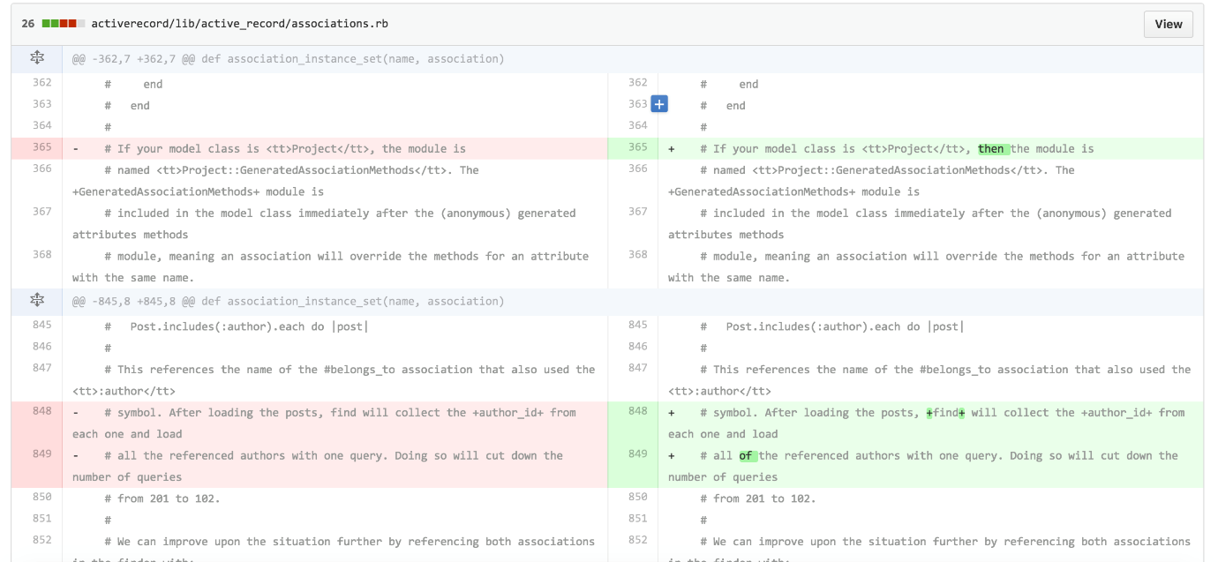
Figure 15 Comparison of changes made to a file between commits

4.5.2 Continuous Integration Software
One of the main objectives of test-driven development is to rapidly test the changes being carried out against a set of automated tests before committing those changes to the codebase (Beck, 2003). Utilising continuous integration (CI) software allows developers to do just that. The purpose of the software is to check a given code repository whenever a change is attempting to be committed and from there a set list of commands are run that are predefined by the user to attempt to compile the project with the new code and upon completion return feedback based on the outcome (Islam and Zibran, 2017). For continuous integration software to work, all the code required for the project must be stored in the repository and once a change has been pushed to the repository, the software will run the list of commands to begin compiling the code.
Integrating the continuous integration software with a version control system allows developers to receive feedback on the work they’ve carried out consistently. The process of this can be described as a cycle with the developer making changes to the codebase, committing those changes to the version control system which then notifies the continuous integration software to run the predefined tests as shown in the figure below.
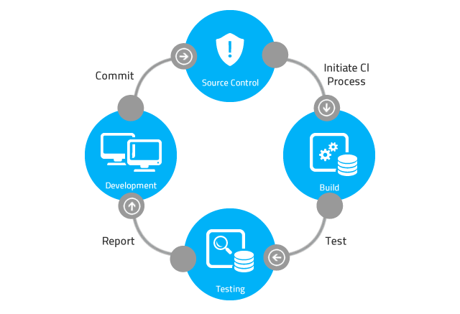
Figure 16 Cycle of software development using TDD (360 Logica, no date)
The feedback returned by the CI, whether the program was able to compile successfully or not, will need to ensure that it is appropriate for the student based on the factors identified in the research prior. The benefit to such an approach is that the student will gain more and more experience of troubleshooting their work and thus a better understanding of the concepts of programming via through the regular and helpful feedback given that will point them in the right direction.

4.6 Summary of Literature Review
In summary, the test-driven approach to development will be an important software development methodology for students to learn as it gives them the experience of developing using a form of agile development which is heavily utilised in industry. The test-driven approach is more appropriate to use at this stage of a student’s career as it allows them to rapidly receive feedback from the work they produce which will be integral to reinforcing their understanding and knowledge of the abstract concepts of programming and how they can implement those concepts into practice.
The learning platform must ensure that the feedback given to the students does not provide them with the exact solution to the problem as otherwise it may negatively affect the student’s problem-solving skills. It will be more beneficial to their learning if they can resolve any errors with the hints given. The learning platform must consider the main issues student’s face in terms of programming are accounted for and provide further assistance in terms of the level of feedback required.
The research has identified the importance of feedback to a student’s learning and that there are three key areas of feedback:
- Feedback from lecturer
- Feedback from the development environment
- Feedback from testing
The research has identified that although there were papers on the usage of version control systems as a learning platform there was a lack of coverage of the usage of version control systems with continuous integration software and whether combining these two technologies would be beneficial for the students.
For the project, Github Classroom has been selected as the version control system of choice as it is already utilised in several courses at the university. The project has opted to utilise Travis CI as the continuous integration software as the research can acquire a free education licence to use the technology. The project will integrate these two technologies and discover how useful such a system is for novice programmers.

4.7 References
360 Logica (no date) The-Existing-Challenges-of-Continuous-Integration-CI.png (640×437). Available at: https://www.360logica.com/blog/wp-content/uploads/2015/08/The-Existing-Challenges-of-Continuous-Integration-CI.png (Accessed: 7 November 2019).
Abrahamsson, P. et al. (2002) ‘Agile software development methods: Review and analysis’, VTT Publications, pp. 3–107. Available at: http://www.vtt.fi/inf/pdf/publications/2002/P478.pdf. (Accessed: 8 November 2019).
Agile Alliance (no date) Pair Programming: Does It Really Work? | Agile Alliance, Agile Alliance. Available at: https://www.agilealliance.org/glossary/pairing/#q=~(infinite~false~filters~(postType~(~’page~’post~’aa_book~’aa_event_session~’aa_experience_report~’aa_glossary~’aa_research_paper~’aa_video)~tags~(~’pair*20programming))~searchTerm~’~sort~false~sortDirecti (Accessed: 8 November 2019).
Aksenov, P. (2013) ‘Stanislav Petrov: The man who may have saved the world’, BBC News Magazine, pp. 6–8. Available at: https://www.bbc.co.uk/news/world-europe-24280831 (Accessed: 5 November 2019).
ARCC (2018) GitHub_Flow_steps.png (700×231), Advanced Research Computing Center (ARCC). Available at: https://arccwiki.uwyo.edu/images/1/19/GitHub_Flow_steps.png (Accessed: 7 November 2019).
Atlassian (2019) Version Control Software: An Overview | Bitbucket. Available at: https://bitbucket.org/product/version-control-software (Accessed: 5 November 2019).
Baldwin, L. P. and Macredie, R. D. (1999) ‘Beginners and programming: Insights from second language learning and teaching’, Education and Information Technologies. Kluwer Academic Publishers, 4(2), pp. 167–179. doi: 10.1023/A:1009652001566.
Beck, K. (2003) Test-driven Development: By Example, Addison-Wesley. Available at: https://books.google.co.uk/books?hl=en&lr=&id=CUlsAQAAQBAJ&oi=fnd&pg=PR7&dq=test-driven+development+&ots=QBiU3d4LO-&sig=xT65uIRkEB4JPyegm8aS37QLIxY&redir_esc=y#v=onepage&q=test-driven development&f=false (Accessed: 10 October 2019).
Black, T. (2006) ‘Helping novice programming students succeed’, Journal of Computing Sciences in Colleges, 22(2), pp. 109–114. Available at: https://dl.acm.org/citation.cfm?id=1181922 (Accessed: 18 October 2019).
Blueprint (2011) Agile Methodologies, VerisonOne. Agile Made Easier. Available at: https://www.blueprintsys.com/agile-development-101/agile-methodologies (Accessed: 8 November 2019).
Brady, T. and Davies, A. (2010) ‘From hero to hubris - Reconsidering the project management of Heathrow’s Terminal 5’, International Journal of Project Management, 28(2), pp. 151–157. doi: 10.1016/j.ijproman.2009.11.011.
Butler, M. and Morgan, M. (2007) ‘Learning challenges faced by novice programming students studying high level and low feedback concepts’, in ASCILITE 2007 - The Australasian Society for Computers in Learning in Tertiary Education, pp. 99–107.
Casteren, W. Van (2017) ‘The Waterfall Model and the Agile Methodologies : A comparison by project characteristics’, (February), pp. 1–6. doi: 10.13140/RG.2.2.36825.72805.
Clynes, M. P. and Raftery, S. E. C. (2008) ‘Feedback: An essential element of student learning in clinical practice’, Nurse Education in Practice, 8(6), pp. 405–411. doi: 10.1016/j.nepr.2008.02.003.
Cottmeyer, M. (2009) The Software Requirements Balancing Act, LeadingAgile. Available at: https://www.leadingagile.com/2009/04/the-software-requirements-balancing-act/ (Accessed: 5 November 2019).
Curtis, B., Krasner, H. and Iscoe, N. (1988) ‘A FIELD STUDY OF THE SOFTWARE DESIGN PROCESS FOR LARGE SYSTEMS’, Communications of the ACM November, 31(11).
Dabbish, L. et al. (2012) Social Coding in GitHub: Transparency and Collaboration in an Open Software Repository Human Factors; Design. Available at: http://git-scm.com/ (Accessed: 7 November 2019).
Davis Alan (2004) ‘Just Enough Requirements Management Process’, pp. 1–20. Available at: www.dorsethouse.com (Accessed: 4 November 2019).
Dehaghani, S. M. H. and Hajrahimi, N. (2013) ‘Which factors affect software projects maintenance cost more?’, Acta Informatica Medica. Avicena Publishing, 21(1), pp. 63–66. doi: 10.5455/aim.2012.21.63-66.
Demicoli, C. (2017) Analyzing Software Failure on the NASA Mars Climate Orbiter. Available at: https://blog.cdemi.io/analyzing-software-failure-on-the-nasa-mars-climate-orbiter/ (Accessed: 5 November 2019).
Feliciano, J., Storey, M. A. and Zagalsky, A. (2016) ‘Student experiences using GitHub in software engineering courses: A case study’, in Proceedings - International Conference on Software Engineering. New York, New York, USA: ACM Press, pp. 422–431. doi: 10.1145/2889160.2889195.
Gennarelli, V. (2017) Real-time feedback for students using continuous integration tools - The GitHub Blog, Github blog. Available at: https://github.blog/2017-03-01-real-time-feedback-for-students-using-continuous-integration-tools/ (Accessed: 8 November 2019).
Gennarelli, V. (2019) How GitHub Classroom and Travis CI improved students’ grades - The GitHub Blog, Github blog. Available at: https://github.blog/2019-02-12-how-github-classroom-and-travis-ci-improved-students-grades/ (Accessed: 10 October 2019).
Github (2019) The State of the Octoverse celebrates a year of building across teams, time zones, and millions of merged pull requests. Available at: https://octoverse.github.com/ (Accessed: 7 November 2019).
Github (no date) GitHub Glossary - GitHub Help. Available at: https://help.github.com/en/github/getting-started-with-github/github-glossary (Accessed: 7 November 2019).
Gokhale, A. A. (1995) ‘Collaborative Learning Enhances Critical Thinking’, Journal of Technology Education. Virginia Tech Libraries, 7(1). doi: 10.21061/jte.v7i1.a.2.
Gröner, M. and Nance, R. (2002) ‘Capturing Requirements Meeting Customer Intent: A Structured Methodological Approach’. doi: 10.1017/CBO9781107415324.004.
Haefliger, S., Von Krogh, G. and Spaeth, S. (2008) ‘Code reuse in open source software’, Management Science, 54(1), pp. 180–193. doi: 10.1287/mnsc.1070.0748.
Highsmith, J. and Cockburn, A. (2001) ‘Agile software development: The business of innovation’, Computer, pp. 120–122. doi: 10.1109/2.947100.
Hossain, E., Ali Babar, M. and Paik, H. Y. (2009) ‘Using scrum in global software development: A systematic literature review’, in Proceedings - 2009 4th IEEE International Conference on Global Software Engineering, ICGSE 2009, pp. 175–184. doi: 10.1109/ICGSE.2009.25.
Islam, M. R. and Zibran, M. F. (2017) ‘Insights into Continuous Integration Build Failures’, in IEEE International Working Conference on Mining Software Repositories. IEEE Computer Society, pp. 467–470. doi: 10.1109/MSR.2017.30.
Kanawade, N. (2017) What is VCS (Version Control System)? 7 ways to choose perfect VCS for your project! | LinkedIn. Available at: https://www.linkedin.com/pulse/what-vcs-version-control-system-7-ways-choose-perfect-nilesh-kanawade/ (Accessed: 5 November 2019).
Kienitz, P. (2019) Most Expensive Software Mistakes, DCSL Software Ltd. Available at: https://www.dcslsoftware.com/most-expensive-software-mistakes/ (Accessed: 5 November 2019).
Lahtinen, E., Ala-Mutka, K. and Järvinen, H.-M. (2005) ‘A study of the difficulties of novice programmers: Proceedings of the 10th Annual SIGCSE Conference on Innovation and Technology in Computer Science Education, June 27-29, 2005, Monte de Caparica, Portugal’, in ITiCSE`05, pp. 14–18. doi: 10.1145/1151954.1067453.
Lawrance, J., Jung, S. and Wiseman, C. (2013) ‘Git on the cloud in the classroom’, in SIGCSE 2013 - Proceedings of the 44th ACM Technical Symposium on Computer Science Education, pp. 639–644. doi: 10.1145/2445196.2445386.
Loeliger, J. and McCullough, M. (2012) Version Control with Git: Powerful Tools and Techniques for Collaborative Software Development. Available at: https://books.google.co.uk/books?hl=en&lr=&id=aM7-Oxo3qdQC&oi=fnd&pg=PR3&dq=what+is+version+control+software&ots=39AfGFYgxf&sig=AUww9897kuKcfN9s-G3uUViTZRk&redir_esc=y#v=onepage&q=what is version control software&f=false (Accessed: 5 November 2019).
Mhashi, M. M. and Alakeel, A. L. I. M. (2013) ‘Difficulties Facing Students in Learning Computer Programming Skills at Tabuk University’, Recent Advances in Modern Educational Technologies, pp. 15–24.
Millward, D. (2008) Heathrow: Terminal 5 causes worst delays for seven years - Telegraph, Telegraph. Available at: https://www.telegraph.co.uk/travel/2117958/Heathrow-Terminal-5-causes-worst-delays-for-seven-years.html (Accessed: 5 November 2019).
Nagele, C. (2015) An introduction to version control, Beanstalk Guides. Available at: http://guides.beanstalkapp.com/version-control/intro-to-version-control.html#basic-concepts (Accessed: 7 November 2019).
Plaice, J. and Wadge, W. W. (1993) ‘A New Approach to Version Control’, IEEE Transactions on Software Engineering, 19(3), pp. 268–276. doi: 10.1109/32.221137.
Radigan, D. (2017) Feature branching your way to greatness, Atlassian. Available at: https://www.atlassian.com/agile/software-development/branching (Accessed: 7 November 2019).
Rasmusson, J. (no date) Agile vs. Waterfall, Agile In a Nutshell. Available at: http://www.agilenutshell.com/agile_vs_waterfall (Accessed: 8 November 2019).
Rising, L. and Janoff, N. S. (2000) ‘Scrum software development process for small teams’, IEEE Software, 17(4), pp. 26–32. doi: 10.1109/52.854065.
Royce, D. W. W. (1970) ‘Managing the Development of large Software Systems’, Ieee Wescon, (August), pp. 1–9.
Scrum Institute (2007) The Scrum Product Backlog - International Scrum Institute, International Scrum Institute. Available at: https://www.scrum-institute.org/The_Scrum_Product_Backlog.php (Accessed: 8 November 2019).
Sentance, S. and Csizmadia, A. (2017) ‘Computing in the curriculum: Challenges and strategies from a teacher’s perspective’, Education and Information Technologies. Springer New York LLC, 22(2), pp. 469–495. doi: 10.1007/s10639-016-9482-0.
StackExchange Inc (2017) ‘Stack Overflow Developer Survey 2017’, Stack Overflow, (3), pp. 1–42. Available at: https://insights.stackoverflow.com/survey/2017 (Accessed: 7 November 2019).
Stephenson, A. G. et al. (1999) Mars Climate Orbiter Mishap Investigation Board Phase I Report, National Aeronautics and Space Administration. doi: 10.1145/3059454.3059463.
Thakurta, R. (2013) ‘Impact of Scope Creep on Software Project Quality’, Vilakshan: The XIMB Journal of Management, 10(1), pp. 37–46. Available at: https://xub.edu.in/pdf/Vilakshan-Sample-Article.pdf (Accessed: 4 November 2019).
Trigunarsyah, B. and Solaiman, S. Al (2016) The Impact of Client Involvement on Project Performance: Case of the Kingdom of Saudi Arabia, Proceedings of the CIB World Building Congress 2016. Available at: https://www.researchgate.net/publication/303939964_The_Impact_of_Client_Involvement_on_Project_Performance_Case_of_the_Kingdom_of_Saudi_Arabia (Accessed: 4 November 2019).
Wells, D. (1997) Pair Programming. Available at: http://www.extremeprogramming.org/rules/pair.html (Accessed: 8 November 2019).
Williams, L. et al. (2000) ‘Strengthening the case for pair programming’, IEEE Software, 17(4), pp. 19–25. doi: 10.1109/52.854064.
Winters, F. (2003) ‘The Top Ten Reasons Projects Fail ( Part 7 ) by Frank Winters’, (Part 7). Available at: https://www.projectmanagement.com/articles/187449/The-Top-Ten-Reasons-Projects-Fail--Part-7- (Accessed: 5 November 2019).
Zagalsky, A. et al. (2015) ‘The Emergence of GitHub as a Collaborative Platform for Education’. doi: 10.1145/2675133.2675284.
Zamansky, M. (2019) Github Classroom and Travis CI, Cestlaz.github.io. Available at: https://cestlaz.github.io/post/github-classroom-travis/ (Accessed: 10 October 2019).
Zowghi, D. and Nurmuliani, N. (2002) ‘A study of the impact of requirements volatility on software project performance’, in Proceedings - Asia-Pacific Software Engineering Conference, APSEC. IEEE Computer Society, pp. 3–11. doi: 10.1109/APSEC.2002.1182970.

Design
With the project focusing on the integrations of various technologies, the project deemed it necessary to discuss each technology separately as to provide a better overall understanding of what that piece of technology will do and how it intends to integrate into the overall interactive learning platform.

Implementation

